**JEWELRY SHOPPING WEBSITE**

**FEATURES:**

* Online shopping website where customers can view fashion jewelry, add items to their cart, process checkout and view their orders.
* Admin can manage products, customers and orders.
* Admin can access REST api calls and generate xml and json data.

**PROJECT FOLDER STRUCTURE:**

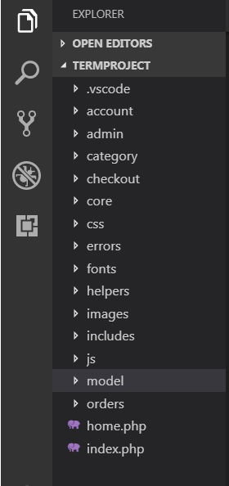

**ACCOUNT**:

The account folder contains all the pages related to user account.

**ADMIN:**

The admin folder contains all the admin php pages for adding, viewing and updating products and customers. Admin home page has link for REST api calls for getting all products, products with matching category name and products within specified price range (products will be displayed by price and not listprice for filtering)

**CATEGORY**:

The category folder contains the product’s pages with product details.

**CHECKOUT**:

The checkout folder has all the folders for displaying cart and checkout pages.

**CORE**:

Core has init.php file which has database connection string.

**IMAGES**:

Images folder contains all project related images.

**INCLUDES**:

The includes folder contains page headers and footer that are included in all pages.

**MODEL**:

Model folder has all the models required for the project.

**TECHNOLOGIES USED :** PHP and MYSQL (xampp)

**INSTRUCTIONS TO INSTALL & RUN PROJECT**

1. Unzip the project folder ‘TermProject’ in the xampp htdocs folder.
2. The database file named ‘jewelrydb’ is inside /TermProject/database/jewelrydb.
3. Create a database in mysql with name jewelrydb and import the datbase file into it. The databae file has all the dummy data.
4. Database connection user is (host: root, pwd:’’, database: jewelrydb)
5. Admin credntials : [admin@admin.com](mailto:admin@admin.com), password: admin
6. Customer credentials: [john@doe.com](mailto:john@doe.com), password: john123

**PROJECT NAVIGATION**

**USER**

1. Website starts with <http://localhost/TermProject/> this is the login page for customer. Enter [john@doe.com](mailto:john@doe.com) as email and ‘john123’ as password.
2. After login, user will be redirected to <http://localhost/TermProject/home.php?user=John>
3. You can use navigation menu to navigate through the website and browse jewelry collection.
4. Select any product and click view details to view its details. The Details view shows the description of item and quantity left in stock. You can add the product to your cart.
5. In cart, you can update any product by changing its quantity and click update. You can also delete an item by setting its quantity to zero and clicking update.
6. Checkout cart will take you to the checkout page, where you can provide your shipping, billing and payment information to proceed to checkout. When you hit place order, your cart items will be stored in the database. An order number will be generated for your reference.
7. Every order has a unique order number. Customers can view their orders details in Account-> My orders. Select any order to view its full details.
8. Logout in Account->Logout will log the customer out of the session.

**ADMIN**

1. The admin part can be accessed via Admin link in footer

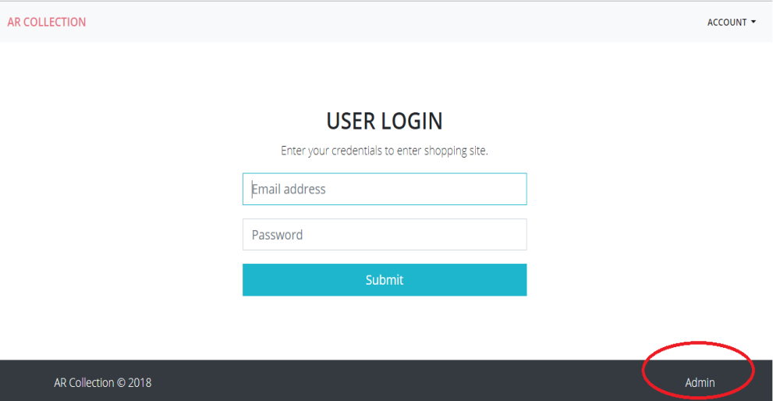

1. You can also access admin section through <http://localhost/TermProject/admin/>
2. Use admin credentials to enter admin section [email: [admin@admin.com](mailto:admin@admin.com), pwd: admin]
3. After login, adminw ill be redirected to <http://localhost/TermProject/admin/home.php>

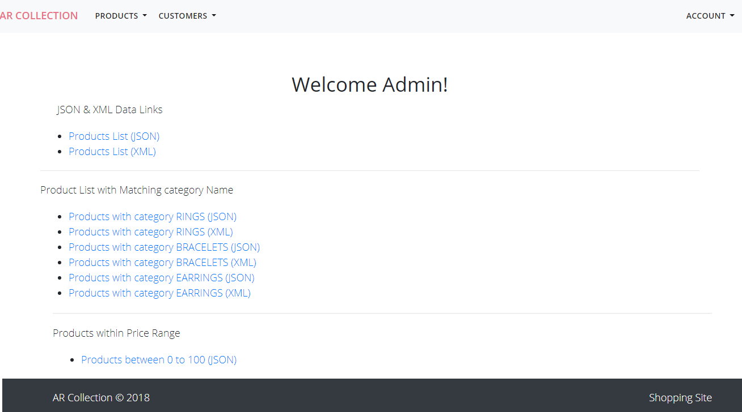

1. On Admin Home, REST Api links are available for viewing product list, products by matching category name and products within specified price range. You can change the price range in the link to get the result. Note however the products are shown on the basis of price (current price of item) and not the list price (original price).
2. Admin view products in using Products -> show products link. The list of all products in the database will be displayed.
3. Admin can view a particular product by clicking view details and edit or delete a product.
4. In Products -> Add Product , Admin can add a new poduct.
5. In Customers->show Customers will show list of all customers. By clicking view details of any customer shows all orders of that particular customer. IF you click on a particular order for that customer, all details for that order will be displayed. Here admin can edit any customer product and also update the order status for that product. (as requested in project document)